Dear Sir/Madam,
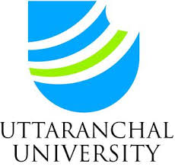 | UTTARANCHAL UNIVERSITY  Internal Quality Assurance Cell (IQAC)
 | Employer Curriculum Feedback Form
Thanks for visiting the Uttaranchal University for campus recruitment. We are grateful to you for providing opportunity of employment to our students with your esteemed organization. We appreciate if you can spare your precious time for filling out this feedback form. It will help us further to improve industry-based curriculum for potential employment.
S.No. | The Descriptor | Strongly agree | Agree | Neutral | Disagree | Strongly disagree
01 | The program caters to local, national, regional and global developmental needs.
02 | The programme curriculum was needed on the basis of requirements of industry, society, and the environment.
03 | The Program provides technical knowledge as per the industry needs.
04 | The program contains the courses which fulfils the required skills and leadership qualities.
05 | Ability to demonstrate solve problems and think creatively.
06 | Ability to communicate effectively.
07 | The curriculum of the program covers the aspects of employability, higher learning and entrepreneurial attitude.
08 | The curriculum of the programme makes students ethically & socially responsible professionals.
09 | Ability to use their domain knowledge effectively in their job.

Any new course suggested for your industry to recruit now or in the future.
________________________________________________________________
________________________________________________________________

Any other points to improve the curriculum / student quality as per industry need:
________________________________________________________________

________________________________________________________________
Suggestions regarding opening of a new program:

__________________________________________________________________________________

Name: Designation:

Name of organization:

Email ID: Date:

Signature of the Employer

